Project Report

# Introduction

A credit card allows you to spend money you don't have at the time that you can then pay back at a later date. Even if you do have the money available, you can often benefit from using your credit card anyway and then paying back the balance in full before the interest properly kicks in. Credit Cards are used by a

large section of the society. It’s essential that a customer segmentation must be done so as to formulate

a Marketing strategy on how to increase the demand for Credit Cards with attractive financial features.

# Problem Statement

This case requires trainees to develop a customer segmentation to define marketing strategy. The sample dataset summarizes the usage behavior of about 9000 active credit card holders during the last 6 months. The file is at a customer level with 18 behavioral variables.

# Data

Understanding of data is the very first and important step in the process of finding solution of any business problem. Here in our case our company has provided a data set with following features, we need to go through each and every variable of it to understand and for better functioning.

* Size of Dataset Provided: - 8950 rows, 18 Columns
* Missing Values: Yes
* Outliers Presented: Yes

Below mentioned is a list of all the variable names with their meanings:

* CUST_ID- Credit card holder ID
* BALANCE- Monthly average balance (based on daily balance averages)
* BALANCE_FREQUENCY- Ratio of last 12 months with balance
* PURCHASES- Total purchase amount spent during last 12 months
* ONEOFF_PURCHASES -Total amount of one-off purchases
* INSTALLMENTS_PURCHASES- Total amount of installment purchases
* CASH_ADVANCE Total cash-advance amount
* PURCHASES_ FREQUENCY-Frequency of purchases (percentage of months with at least on purchase)
* ONEOFF_PURCHASES_FREQUENCY- Frequency of one-off-purchases
* PURCHASES_INSTALLMENTS_FREQUENCY- Frequency of installment purchases
* CASH_ADVANCE_ FREQUENCY- Cash-Advance frequency
* CASH_ADVANCE_TRX -Average amount per cash-advance transaction
* PURCHASES_TRX -Average amount per purchase transaction
* CREDIT_LIMIT- Credit limit
* PAYMENTS-Total payments (due amount paid by the customer to decrease their statement balance) in the period
* MINIMUM_PAYMENTS -Total minimum payments due in the period.
* PRC_FULL_PAYMENT- Percentage of months with full payment of the due statement balance
* TENURE- Number of months as a customer

# Methodology

### Pre-Processing

When we required to build a predictive model, we require to look and manipulate the data before we start modelling which includes multiple preprocessing steps such as exploring the data, cleaning the data as well as visualizing the data through graph and plots, all these steps is combined under one shed which is Exploratory Data Analysis, which includes following steps:

* Data Exploration and Cleaning
* Missing Value Analysis
* Deriving new Key Performance Indicators(KPI’s)
* Outlier Treatment
* Insights from New KPI’s and Data Visualisation

### Applying Machine Learning(ML) Algorithms

Once all the Pre-Processing steps has been done on our data set, we will now further move to our next step which is applying ML Algorithms. ML Algorithms plays an important role to find out the good inferences from the data. Choice of models depends upon the problem statement and data set. As per our problem statement and dataset, we will try some models on our preprocessed data and post comparing the output results we will select the best suitable model for our problem. As per our data set following models need to be tested on K-Means Clustering

* Principal Component Analysis(PCA)
* Silhouette Coefficient

### Checking Performance Metrics

We have to check the validating performance with 2 metrics namely

* Calinski Harabaz Score
* Silhouette Score

**Data Pre Processing**

### Data exploration and Cleaning (Missing Values and Outliers)

The very first step which comes with any data science project is data exploration and cleaning which includes following points as per this project:

* 1. Drop the CUST_ID column as it is not relevant
  2. As we know we have some missing values in CREDIT_LIMIT and MINIMUM_PAYMENTS, we have to remove those missing values and replace them with median.

### Deriving new Key Performance Indicators(KPI)

1. Monthly average purchase and cash advance amount
2. Purchases by type (one-off, installments)
3. Average amount per purchase and cash advance transaction,
4. Limit usage (balance to credit limit ratio),
5. Payments to minimum payments ratio etc.
6. Advanced reporting: Use the derived KPIs to gain insight on the customer profiles.
7. Identification of the relationships/ affinities between services.

### Creating some new variables

We created new variables from our existing variables in our Dataset

* + Monthly Average Purchases

Monthly Average Purchases = Purchases/Tenure

* + Monthly Cash Advance

Monthly Cash Advance = Cash Advance/Tenure

* + Purchase Type

We combine all forms of Purchase given in our Dataset and form this new variable of Purchase Type comprising of:

1. Both Oneoff Installment
2. Installment
3. None
4. Oneoff
   * Limit Usage

Limit Usage = Balance/Credit Limit

* + Payment Minpay

Payment Minpay = Payments/Minimum Payments

### Outlier Treatment

Since there are variables having extreme values, I am doing log-transformation on the dataset to remove outlier effect.

Log Transformation: This method is often used to reduce the variability of data including outlying observation.

It’s often preferred when the response variable follows exponential distribution or is right- skewed**.**

### Newly Extracted Variables

* + BALANCE
  + BALANCE_FREQUENCY
  + PURCHASES
  + ONEOFF_PURCHASE
  + INSTALLMENTS_PURCHASES
  + CASH_ADVANCE
  + PURCHASES_FREQUENCY
  + ONEOFF_PURCHASES_FREQUENCY
  + PURCHASES_INSTALLMENTS_FREQUENCY
  + CASH_ADVANCE_FREQUENCY
  + CASH_ADVANCE_TRX
  + PURCHASES_TRX
  + CREDIT_LIMIT
  + PAYMENTS
  + MINIMUM_PAYMENTS
  + PRC_FULL_PAYMENT
  + TENURE
  + Monthly_avg_purchase
  + Monthly_cash_advance
  + limit_usage
  + payment_minpay

### Insights from New KPI’s and Data Visualization

We will derive the relations between the indicators by means of visualization plots:

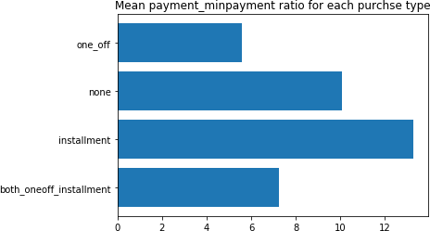

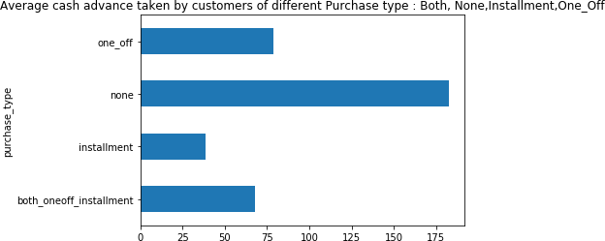Customers with installment purchases are paying dues

Customers who don't do either one-off or installment purchases take more cash on advance

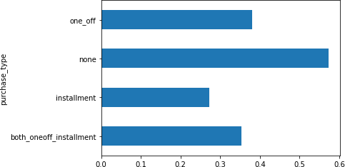

Customers with installment purchases have good credit score

## Applying Machine Learning Algorithms

The first approach would be to create a dummy with the Purchase Type variable that collectively includes:

* Both One Off Installment
* Installment
* None
* One off

After creating the dummy needs to be merged with the original Data Frame. One needs to check whether there are any missing values or not.

As there are no missing values, the next step would be to see whether there is any correlation or not by plotting the correlation graph:

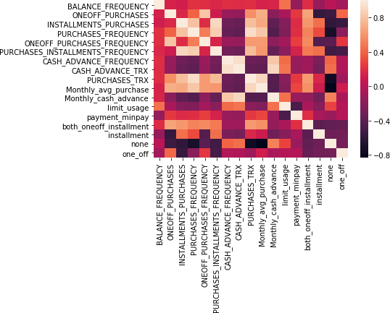

Standardize the data in order to avoid effect of scale on our result. Centering and Scaling will make all features with equal weight.

### Standardization

Standardization is about making sure that data is internally consistent; that is, each data type has the same content and format. Standardized values are useful for tracking data that isn't easy to compare otherwise.

Standardization typically rescales data to have a mean of 0 and a standard deviation of 1.

In this dataset , Standardization must be done in order to avoid effect on scale on our result. Scaling will make all features of equal weight.

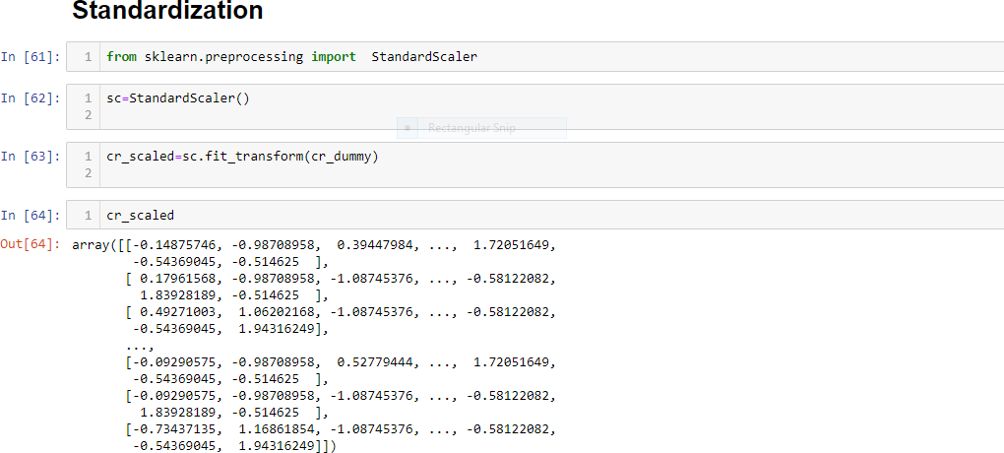

### Principal Component Analysis(PCA)

Principal component analysis (PCA) is a statistical procedure that uses an [transformation](https://en.wikipedia.org/wiki/Orthogonal_transformation) to convert a set of observations of possibly correlated variables (entities each of which takes on various numerical values) into a set of values of [linearly uncorrelated](https://en.wikipedia.org/wiki/Correlation_and_dependence) variables called principal components. This transformation is defined in such a way that the first principal component has the largest

possible [variance](https://en.wikipedia.org/wiki/Variance) (that is, accounts for as much of the variability in the data as possible), and each succeeding component in turn has the highest variance possible under the constraint that it

is [orthogonal](https://en.wikipedia.org/wiki/Orthogonal) to the preceding components. The resulting vectors (each being a [linear combination](https://en.wikipedia.org/wiki/Linear_combination) of the variables and containing n observations) are an uncorrelated [set](https://en.wikipedia.org/wiki/Orthogonal_basis_set). PCA is sensitive to the relative scaling of the original variables.

PCA is mostly used as a tool in [exploratory data analysis](https://en.wikipedia.org/wiki/Exploratory_data_analysis) and for making [predictive models](https://en.wikipedia.org/wiki/Predictive_modeling). It is often used to visualize genetic distance and relatedness between populations.

#### Data Observations

In this report we are clustering the customers as per their spending methods so as to prepare a marketing strategy for the upcoming business year. So here we have a data set of 8950 observations with 17 variables.

The dataset has 17 variables we have to take 17 as our n component.

Find the variance of scaled Data, and after checking the variance it has been found that there are 6 components that has 90% Variance.

Now taking the components we have to use dimensionality reduction so that we don’t overfit out

variables. There are 5 variables for clustering purposes

|  |  |  |  |  |  |  |
| --- | --- | --- | --- | --- | --- | --- |
|  | **0** | **1** | **2** | **3** | **4** | **5** |
| **0** | -0.242841 | -2.759668 | 0.343061 | -0.417359 | -0.007100 | 0.019755 |
| **1** | -3.975652 | 0.144625 | -0.542989 | 1.023832 | -0.428929 | -0.572463 |
| **2** | 1.287396 | 1.508938 | 2.709966 | -1.892252 | 0.010809 | -0.599932 |
| **3** | -1.047613 | 0.673103 | 2.501794 | -1.306784 | 0.761348 | 1.408986 |
| **4** | -1.451586 | -0.176336 | 2.286074 | -1.624896 | -0.561969 | -0.675214 |

### New Variables from Dummy set

* BALANCE_FREQUENCY
* ONEOFF_PURCHASES
* INSTALLMENTS_PURCHASES
* PURCHASES_FREQUENCY
* ONEOFF_PURCHASES_FREQUENCY
* PURCHASES_INSTALLMENTS_FREQUENCY
* CASH_ADVANCE_FREQUENCY
* CASH_ADVANCE_TRX
* PURCHASES_TRX
* Monthly_avg_purchase
* Monthly_cash_advance
* limit_usage
* payment_minpay
* both_oneoff_installment
* installment
* none
* one_off

#### Eigen Vector

The eigenvectors and eigenvalues of a covariance (or correlation) matrix represent the core of a PCA.The eigenvectors (principal components) determine the directions of the new feature space, and the eigenva lues determine their magnitude. In other words, the eigenvalues explain the variance of the data along t he new feature axes. The Eigen Vectors of the columns are given below:

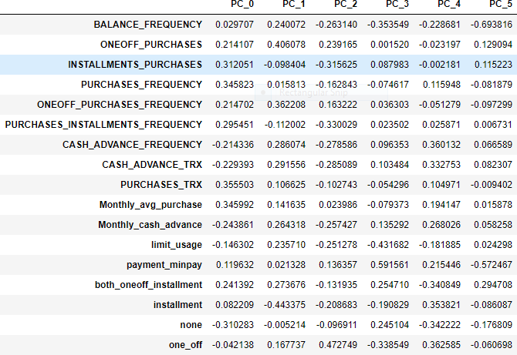

#### Factor Analysis

Factor analysis is a technique that is used to reduce a large number of variables into fewer numbers of factors. This technique extracts maximum common variance from all variables and puts them into a

common score. As an index of all variables, we can use this score for further analysis. The outputs of the Factor Analysis is given below:

|  |  |
| --- | --- |
| PC_0 | 0.402058 |
| PC_1 | 0.180586 |
| PC_2 | 0.147294 |
| PC_3 | 0.081606 |
| PC_4 | 0.065511 |
| PC_5 | 0.041594 |

### K-Means Clustering

K-means clustering is a type of unsupervised learning, which is used with unlabeled dataset. The goal of this algorithm is to find K groups in the data. The algorithm works iteratively to assign each data point to one of K groups based on the features that are provided. Data points are clustered based on feature similarity. The results of the K-means clustering algorithm are:

* The centroids of the K clusters, which can be used to label new data
* Labels for the training data (each data point is assigned to a single cluster)

K-means works by defining spherical clusters that are separable in a way so that the mean value converges towards the cluster center. Because of this, K-Means may underperform sometimes.

In this Dataset based on the type of purchases made by customers and their distinctive behavior exhibited based on the purchase type (as visualized above in Insights from KPI), we have to start off with 4 clusters.

As we do not have known k value so we will find the K. To do that we need to take a cluster range between 1 and 21.

### Elbow Criterion Method

As we do not know the K value we will use Elbow Criterion method between the range 1 to 21. The idea behind elbow method is to run k-means clustering on a given dataset for a range of values of k (e.g k=1 to 10), for each value of k, calculate sum of squared errors (SSE).

Calculate the mean distance between data points and their cluster centroid. Increasing the number of clusters(K) will always reduce the distance to data points, thus decrease this metric, to the extreme of reaching zero when K is as same as the number of data points. So the goal is to choose a small value of k that still has a low SSE.

We run the algorithm for different values of K(say K = 10 to 1) and plot the K values against SSE(Sum of Squared Errors). And select the value of K for the elbow point.

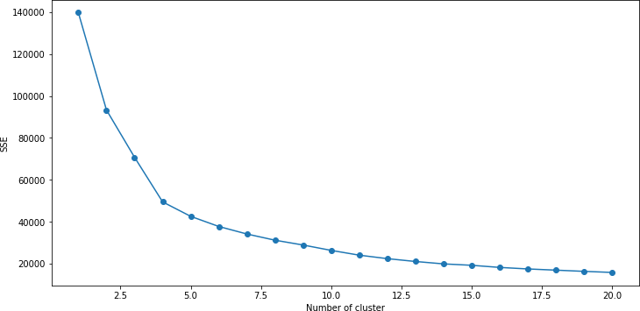

#### Silhouette Coefficient Method

A higher Silhouette Coefficient score relates to a model with better-defined clusters. The Silhouette Coefficient is defined for each sample and is composed of two scores:

* The mean distance between a sample and all other points in the same class.
* The mean distance between a sample and all other points in the next nearest cluster.
* The Silhouette Coefficient is for a single sample is then given as:

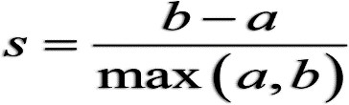

Here in this Dataset we will do a Silhouette Coefficient between range 1 and 21.

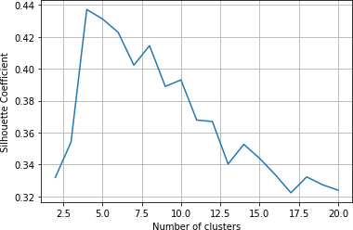

We will use Pair plot to provide us all graph in a single frame. At the same time we have to add the Cluster column as well:

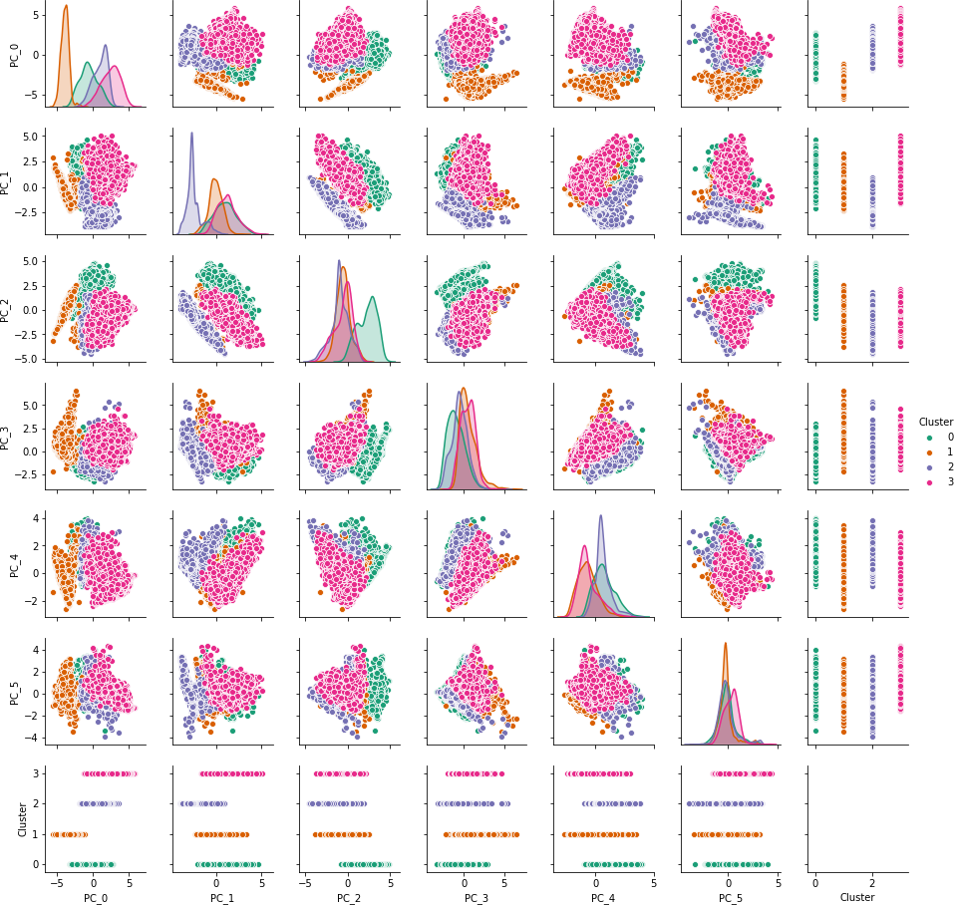

It shows that first two components are able to identify clusters

Now we have done here with principle component now we need to come bring our original data frame and we will merge the cluster with them.

To interpret result we need to use our data frame

Now we will find the Mean value of each variable of each cluster:

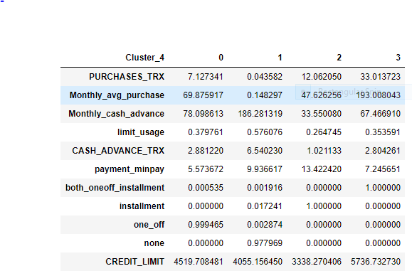

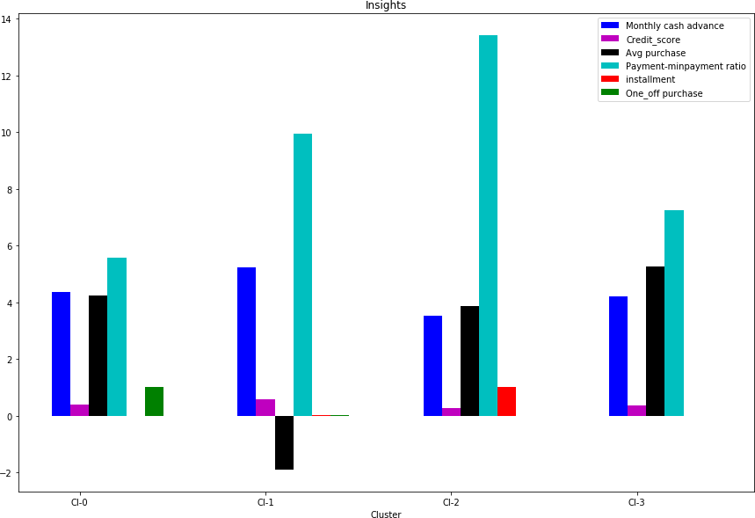Graphical Representation:

Clusters are clearly distinguishing behavior within customers

Now out of 8950 observations let us cluster the customers and find out their percentages

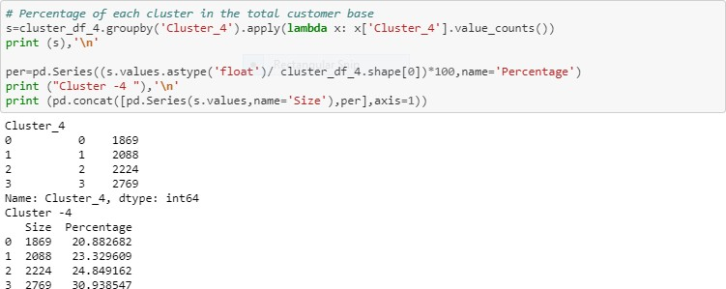

|  |  |  |
| --- | --- | --- |
| **Group** | **Number** | **Percentage** |
| 0 | 1869 | 21% |
| 1 | 2088 | 23% |
| 2 | 2224 | 25% |
| 3 | 2769 | 31% |

Now let’s check the pattern of 5 Cluster

We would find the mean and derive new insights

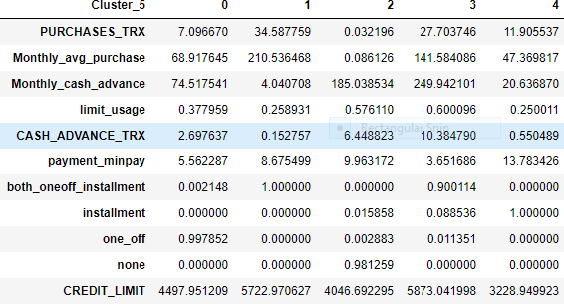

Conclusion With 5 clusters :

We have a group of customers (cluster 1) having highest avergae purchases but there is Cluster 3 also having highest cash advance & secong highest purchase behaviour but their type of purchases are same.

Cluster 0 and Cluster 2 are behaving similar in terms of Credit_limit and Cluster 2 and Cluster 3 have cash transactions is on higher side

There is no distinguishable characters with 5 clusters

Observation with 6 clusters

Like earlier we would derive insights by looking at the mean value of each variables of the clusters

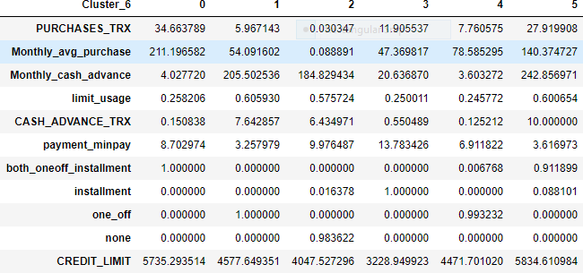

Conclusion with 6 clusters

Nothing much could be inference from 6 clusters

We have a group of customers (cluster 0) having highest average purchases but there is Cluster 5 also having highest cash advance & second highest purchase behaviour but their type of purchases are same.

Cluster 0 and Cluster 5 are behaving similar in terms of Credit_limit and Cluster 1 and Cluster 2 have cash transactions is on higher side

**Checking Performance Matrix**

### Calinski-Harabasz

Calinski-Harabasz is a kind of estimate that can help us chooses the proper clustering number before performing the algorithm.

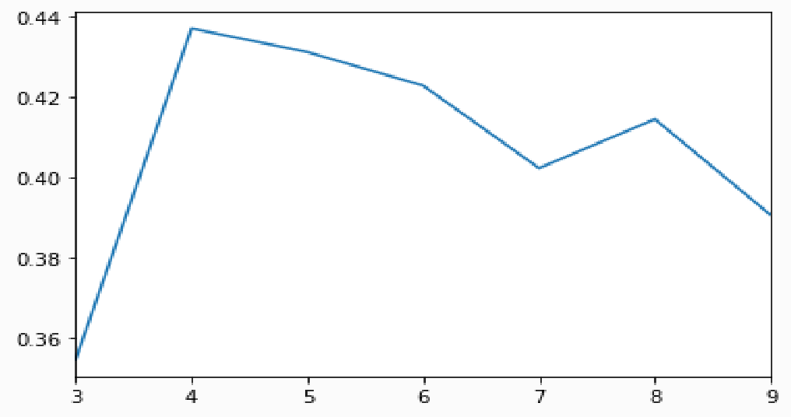

**Silhouette Score**

Silhouette Score refers to a method of interpretation and validation of consistency within [clusters of data.](https://en.wikipedia.org/wiki/Cluster_analysis) The technique provides a succinct graphical representation of how well each object has been classified.

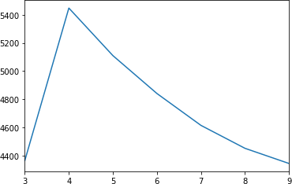

Performance metrics also suggest that K-means with 4 cluster is able to show distinguished characteristics of each cluster.

**Insights with 4 clusters**

1. Cluster 3 is the group of customers who have highest Monthly_avg purchases and doing both one_off installment purchases, have comparatively good credit score. *This group is about* 31% of the total customer base.
2. Cluster 1 is taking maximum advance_cash and is paying comparatively less minimum payment and poor credit_score & doing no purchase transaction. This group is about 23% of the total customer base.
3. Cluster 0 customers are doing maximum One_Off transactions and least payment ratio and credit_score on lower side This group is about 21% of the total customer base.
4. Cluster 2 customers have maximum credit score and are paying dues and are doing maximum installment purchases. This group is about 25% of the total customer base

**The End**